**Conduct a feasibility assessment that contributes to the process of project selection. (P1.2)**

1. **Technical Feasibility**

Technical feasibility is the technical resources that is needed to develop, install, purchase or operate the system (Shelly and J. Rosenblatt, 2019). The proposed system which is e-Donation Application will be develop by using **Adobe Dreamweaver CS6**. So, there are few PC specification that need to be considered by the developer in order to install the software.

Below is the table of the developer’s PC specification and minimum requirement specification of Adobe Dreamweaver CS6.

|  |  |  |
| --- | --- | --- |
| Items | PC Specification Developer | Minimum Requirement |
| Processor | Intel® Core™ i5-7200U (2.5 GHz, up to 3.1 GHz, 3 MB cache, 2 cores) | Intel® Pentium® 4 or AMD Athlon® 64 processor |
| Memory | 4 GB DDR4-2133 SDRAM (1 x 4 GB) | 512 MB of RAM |
| Hard disk | 1 TB 5400 rpm SATA (778 GB free of 1 TB) | 1 GB of available hard-disk space for installation; additional free space required during installation |
| Graphic Display | 1366 x 768 with AMD Radeon™ R5 M430 Graphics (2 GB DDR3 dedicated) | 1280 x 800 display with 16-bit graphics adapter |

Based on the table above, the minimum requirement specification for processor to install Adobe Dreamweaver CS6 is Intel® Pentium® 4 or AMD Athlon® 64 processor. The developer’s PC specification for processor is Intel® Core™ i5-7200U (2.5 GHz, up to 3.1 GHz, 3 MB cache, 2 cores). So, the developer’s PC is suitable to install the software.

Then, the minimum requirement for memory (RAM) to install Adobe Dreamweaver CS6 is 512 MB. While, the developer’s PC specification is 4GB DDR4-2133 SDRAM (1 x 4 GB) which very suitable and adequate to install the software in order to develop the system

Next, the minimum requirement for hard disk in order to install the software is at least the PC has 1 GB of available hard-disk space for installation and additional free space during the installation. Meanwhile, the developer PC specification for hard disk is 1 TB 5400 rpm SATA which now it has 778 GB free of 1 TB which is very adequate to install Adobe Dreamweaver CS6.

Then, the minimum requirement for graphic display in order to install Adobe Dreamweaver CS6 is 1280 x 800 display with 16-bit graphics adapter. While, the developer’s PC specification for graphic display is 1366 x 768 with AMD Radeon™ R5 M430 Graphics (2 GB DDR3 dedicated) which is very suitable and adequate to install the software.

In conclusion in term of technical expertise, there are sufficient resources to manage the development of e-Donation Application since there are enough staff and team member that involved in the project which is project manager, system analyst, system designer, programmer and system tester.

1. **Operational Feasibility**

Operational feasibility is referred to the measure of solving problems with the help of the proposed system. It is also used to determine and identify the problem in system and how the proposed system can help to solve the problem (Evirtualservices.com, 2019). So, there are few problems that has been identified regarding the current system of donation application that has been used by Koperasi KPM Beranang.

Below is the table shows the problem of the current system, the expected functionality of the proposed system and how the proposed system solve the problem.

|  |  |  |
| --- | --- | --- |
| **Problems** | **Functionality (Expected)** | **How it solves the problem** |
| The current manual system is unable to keep track the donation that has been given to the same Organization/  Department | Generate report | The proposed system can help the members of Koperasi KPM Beranang to keep track the donation that has been given to the same Organization/  Department by generating report of selected Organization/ Department from the system database and display the total amount of the donation. |
| The current system only can be managed by one person of member of Koperasi KPM Beranang | Sign up and log in by the members | The proposed system will have sign up and log in form which can be access by members of Koperasi KPM Beranang in order to manage the donation |
| The applicant that want to apply for the donation must write the formal letter and give to one of members of Koperasi KPM Beranang which is not flexible. | Sign up and log in by the applicant and online donation request form | The proposed system will be online-based system which the applicant must sign up and log in to the system. The applicant can fill in the important data in the request form that has been implemented in the system in order to apply for the donation. |

1. **Schedule Feasibility**

Schedule Feasibility is described as the likelihood that a project will be finished by a planned due date within its scheduled time boundaries. If a project has a high likelihood of being finished on time, the feasibility of its timetable is reviewed as high (Taskmanagementguide.com, n.d.). Below is the schedule in order to develop e-Donation Application.

Project Name: e-Donation Application

Start Date: 17/06/2019

End Date: 29/07/2019

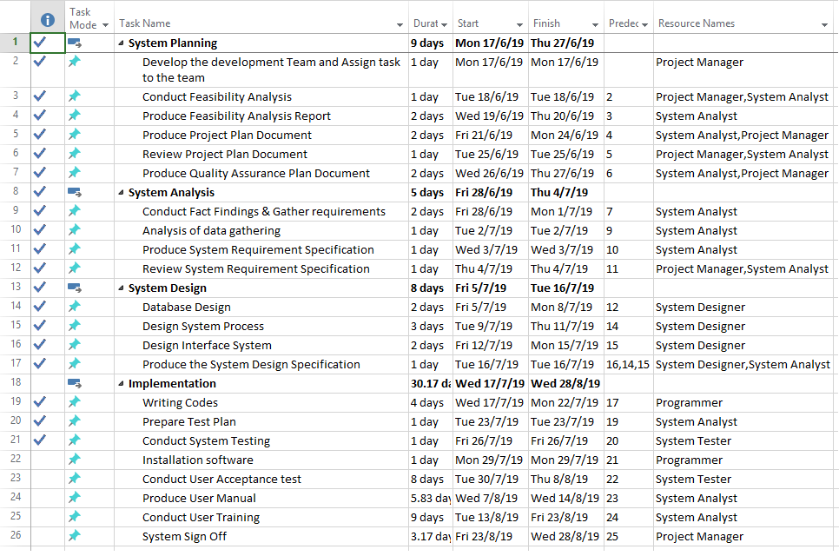Duration: 3 Months

**Schedule for the development of e-Donation Application**

Based on the schedule above, the first stage of development of e-Donation Application is **System Planning**. This stage will be conducted in 9 days which from 17th June 2019 to 27th June 2019. In this stage, there are few task breakdowns that will be conducted. The tasks are develop the development team and assign task to the team, conduct feasibility analysis, produce feasibility analysis report, produce project plan document and produce quality assurance plan document. The team member that will be involve in this stage are Project Manager and System Analyst.

The next stage that will be conducted in this project is **System Analysis**. This stage will be conducted in 5 days from 28th June 2019 until 4th July 2019. The that are involved in this stage are conduct fact findings & gather requirements, analysis of data gathering, produce system requirement specification and review system requirement specification. Project manage and system analyst also will involve in this stage.

The other stage that will be conducted to development e-Donation Application is **System Design**. This stage will be conducted in 8 days which is from 5th July 2019 until 16th July 2019. The task breakdown that will be conducted in this stage are database design, design system process, design interface of the system and produce the system design specification. The team member that will be involved in this stage is only system designer and system analyst.

The last stage that will be conducted is **implementation**. The implementation of e-Donation Application will be conducted in 30.17 days which is from 17th July 2019 until 28th August 2019. The task that will be conducted in this stage are writing codes, prepare test plan, testing and installation software, Conduct User Acceptance test, Produce User Manual, Conduct User Training and System Sign Off. The team member that will be involved in this stage are project manager, system analyst, programmer and tester.

As a conclusion, based on the schedule above, the task breakdown that has been divided is compatible with the analysed date.

1. **Economic Feasibility**

Economic feasibility is to measure of the cost-effectiveness of a project or solution (Webcache.googleusercontent.com, n.d.). Below is the economic feasibility that has been identified for e-Donation Application.

1. Benefits
   * 1. Tangible Benefits

|  |  |
| --- | --- |
| Tangible Benefits (year 1-2) | |
| Error reduction | RM2,500 |
| Increase speed of activity | RM3,700 |
| Cost avoidance | RM3,500 |
| Reduction of salary | RM5,000 |
| Total Tangible benefits | RM14,700 |

Year 1 – RM7,350

Year 2 – RM7,350

* + 1. Intangible Benefits
       1. **Improve the work process**

By implementing e-Donation Application in KPM Beranang, it can lead to time reduction for the both of parties which are the member of Koperasi KPM Beranang and the applicant of the donation. It is because the system is online-based system which can be accessed anywhere and anytime by both of the parties. The system will be implemented with donation request form where the applicant just fill in the form to make donation request instead writing letter which requires a lot of time. The members of Koperasi KPM Beranang also can easily approve the donation by clicking on the approve button which will save more time.

* + - 1. **Can be managed by multiple user**

By implementing e-Donation Application for Koperasi KPM Beranang, it can increase the organizational responsibility. It is because the system can be access by all the members of Koperasi KPM Beranang. The current system only can be managed by one person as it used manual filing but by implementing e-Donation Application, the member can sign up and log in to the system and can easily manage the donation application. So, it can increase the organizational responsibility and performance.

* + - 1. **Timely reliable information**

By implementing e-Donation Application for Koperasi KPM Beranang, it can help for fast and easy data retrieval because the system can save all the important data regarding the donation application in the database. Instead of finding the data in physical file, the member of Koperasi KPM Beranang can easily retrieve the previous data from the database in the system without worrying of the data loses.

1. Cost
   * 1. On Time Cost

|  |  |
| --- | --- |
| Details | Cost |
| Hardware cost | RM1,900 |
| New software cost | RM1,500 |
| Development cost | RM8000 |
| Total | RM11,400 |

* + 1. Recurring Cost

|  |  |
| --- | --- |
| Details | Cost (Year 1-2) |
| Utilities bill | RM400 |
| Staff salary | RM2,000 |
| System Maintenance (Monthly) | RM1,500 |
| Total | RM3,900 |

Year 1 – RM1,950

Year 2 – RM1,950

1. Net Present Value (NPV)

Below is the NPV for e-Donation Application. The start-up cost is RM11,400 and the project required to be developed for 2 years and the discount rate is 10%.

|  |  |  |  |
| --- | --- | --- | --- |
| Year | Cash Flow | Discount factor | Present Value |
| 0 | -(11,400) | 1 | -(11,400) |
| 1 | 5,400 | 0.9091 | 4,909.14 |
| 2 | 5,400 | 0.8264 | 4,462.56 |
| Net Profit: | 600 | NPV: | 2,028.30 |

Below is the NPV for Payroll System. The start-up cost is RM6,800 and the project required to be developed for 2 years and the discount rate is 6%.

|  |  |  |  |
| --- | --- | --- | --- |
| Year | Cash Flow | Discount factor | Present Value |
| 0 | -(10,200) | 1 | -(10,200) |
| 1 | 5,400 | 0.9434 | 5,094.36 |
| 2 | 5,400 | 0.8900 | 4,806.00 |
| Net Profit: | -600 | NPV: | -299.64 |

From the calculation, it shows that NPV for e-Donation Application is 2,028.30 which is a positive value. While, the NPV for Payroll system is -299.64 which is negative value. In conclusion, net profit for e-Donation Application is RM600 which can be achieved in 2 years and the project can be accepted for the development. While, for Payroll System, the net profit is -600 which cannot be achieved and the project cannot be accepted for the development.